Assignment 7: Prepare a series of SQL statements to INSERT new records into the library tables, UPDATE existing records with new information, and DELETE records based on specific criteria. Include BULK INSERT operations to load data from an external source.

SOLUTION:

CREATE TABLE IF NOT EXISTS books (

book_id INT AUTO_INCREMENT PRIMARY KEY,

title VARCHAR(255),

author VARCHAR(255),

publication_year INT,

quantity INT

);

CREATE TABLE IF NOT EXISTS members (

member_id INT AUTO_INCREMENT PRIMARY KEY,

name VARCHAR(255),

email VARCHAR(255),

phone VARCHAR(20)

);

CREATE TABLE IF NOT EXISTS loans (

loan_id INT AUTO_INCREMENT PRIMARY KEY,

book_id INT,

member_id INT,

loan_date DATE,

return_date DATE,

FOREIGN KEY (book_id) REFERENCES books(book_id),

FOREIGN KEY (member_id) REFERENCES members(member_id)

);

INSERT INTO books (title, author, publication_year, quantity)

VALUES

('To Kill a Mockingbird', 'Harper Lee', 1960, 10),

('1984', 'George Orwell', 1949, 8),

('Pride and Prejudice', 'Jane Austen', 1813, 6);

INSERT INTO members (name, email, phone)

VALUES

('John Doe', 'john@example.com', '123-456-7890'),

('Alice Smith', 'alice@example.com', '987-654-3210');

INSERT INTO loans (book_id, member_id, loan_date, return_date)

VALUES

(1, 1, '2024-05-20', NULL),

(2, 2, '2024-05-22', NULL);

UPDATE books

SET quantity = 12

WHERE title = 'To Kill a Mockingbird';

UPDATE members

SET email = 'john.doe@example.com'

WHERE name = 'John Doe';

UPDATE loans

SET return_date = '2024-06-10'

WHERE book_id = 2 AND member_id = 2;

DELETE FROM books

WHERE title = 'Pride and Prejudice';

DELETE FROM members

WHERE name = 'Alice Smith';

DELETE FROM loans

WHERE book_id = 2 AND member_id = 2;

OUTPUT:

1.CREATING TABLES

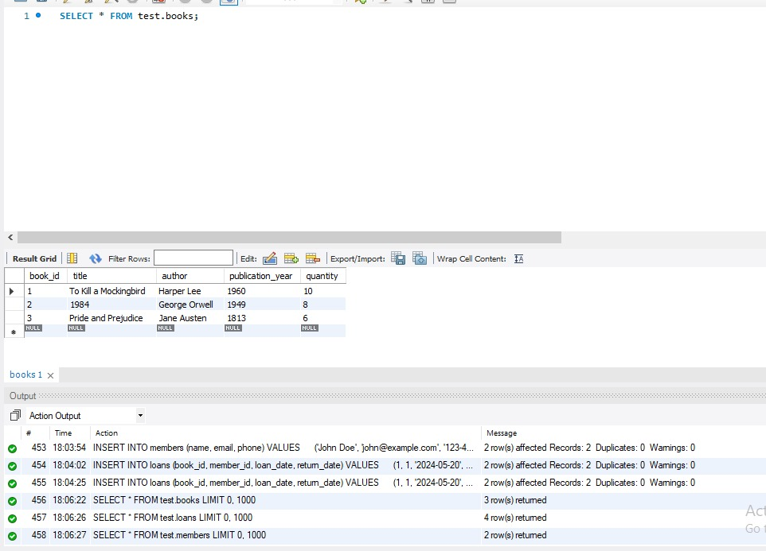

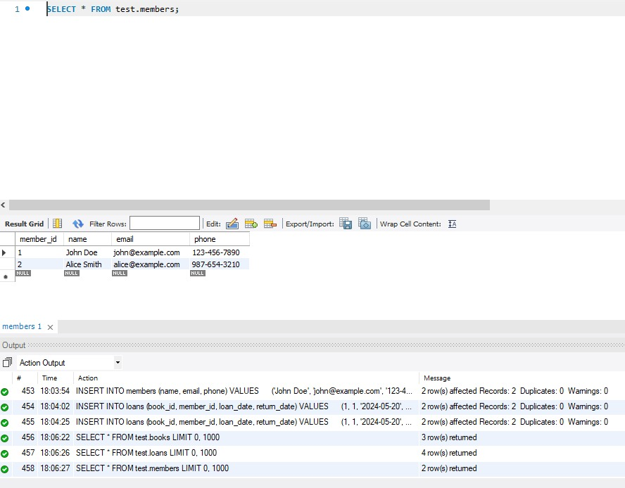

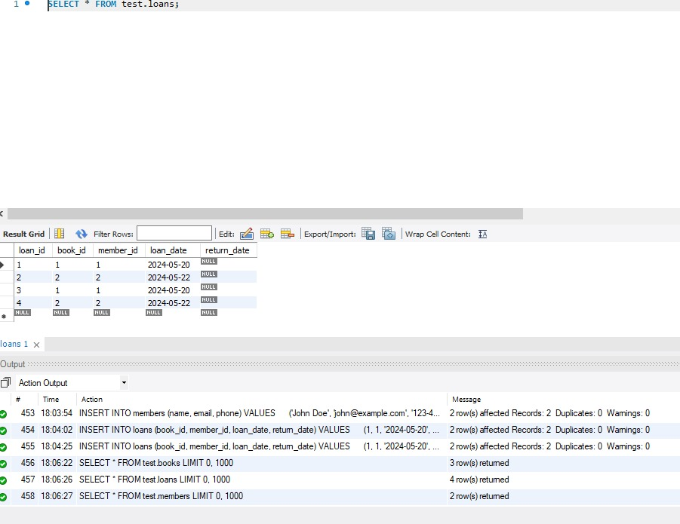

2.UPDATE

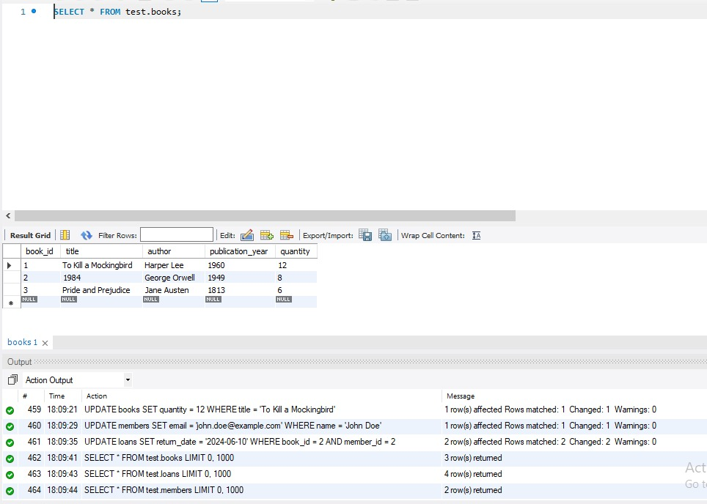

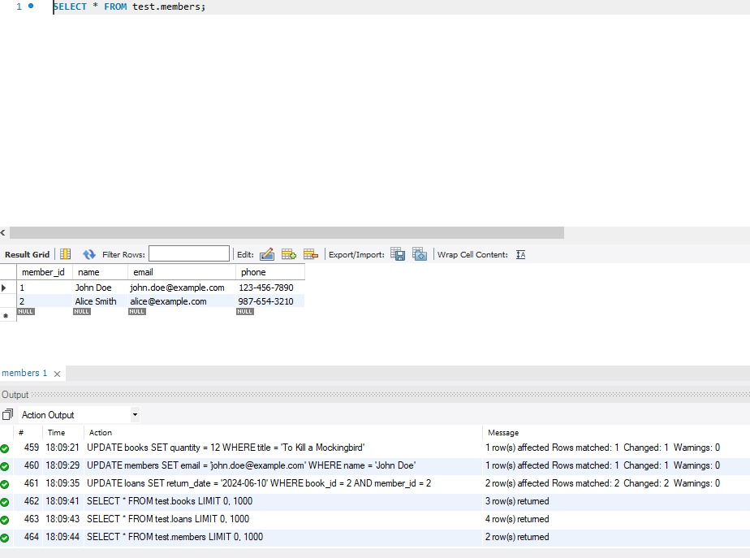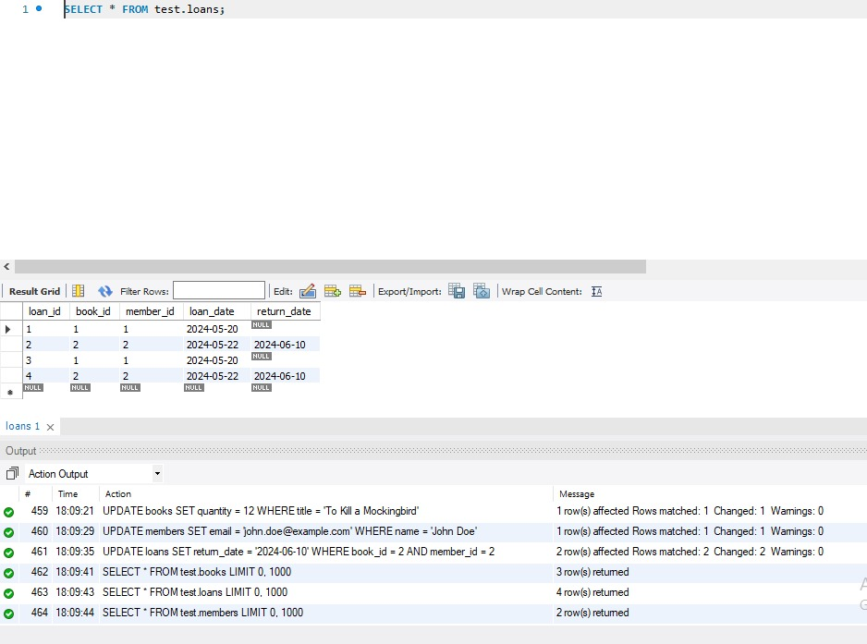

3.DELETE

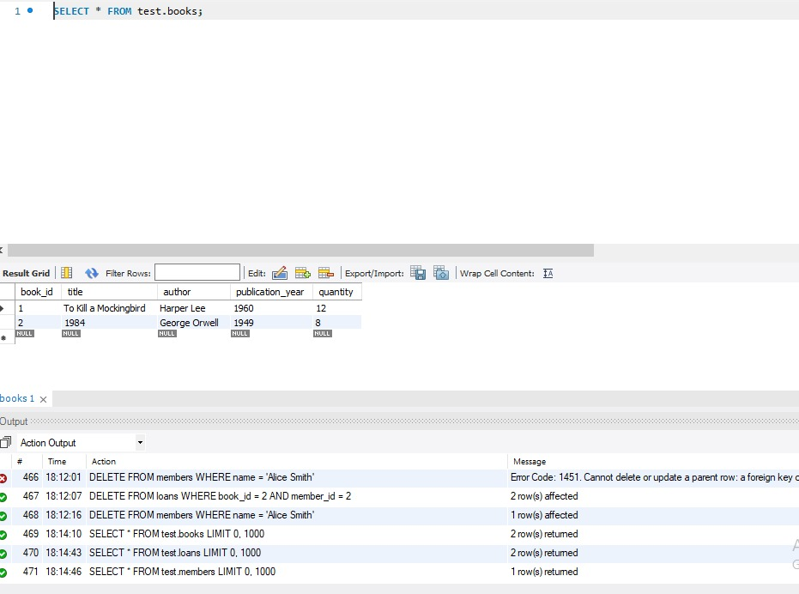

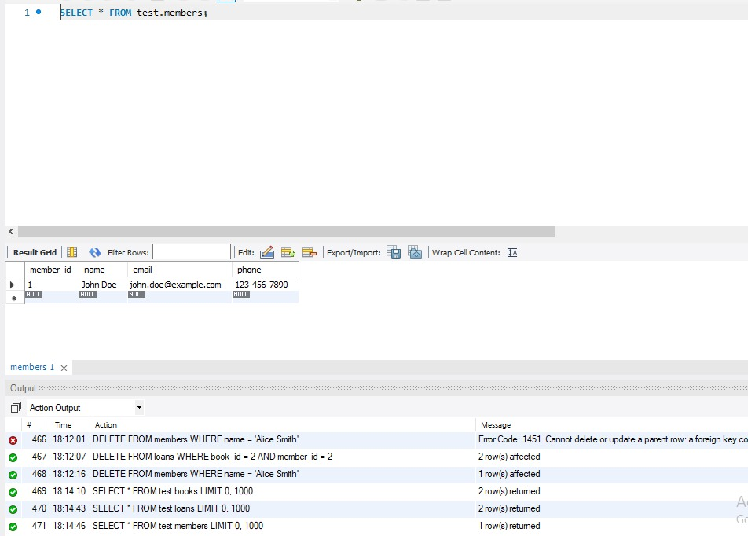

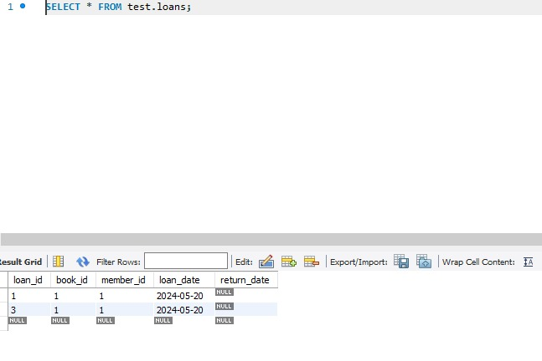

4.BULK

CREATE TABLE sales (

OrderID int,

OrderDate date,

ItemType varchar(50),

SalesChannel varchar(50),

UnitsSold int,

UnitPrice float,

DeliveryDate date,

TotalCost float,

TotalProfit float

);

LOAD DATA INFILE 'C:/ProgramData/MySQL/MySQL Server 8.0/Uploads/sales.csv'

INTO TABLE sales

FIELDS TERMINATED BY ','

LINES TERMINATED BY '\n'

IGNORE 1 LINES;

SHOW VARIABLES LIKE 'secure_file_priv';

select * from sales;

